**Vehicle and Pedestrian Detection using YOLOv8 and OpenCV**

*An Internship Project Report*

*Submitted to*

# DLITHE CONSULTANCY SERVICES PRIVATE LIMITED

*by*

**Aditya R Hegde**

**USN** **4NM20CS015**

Under the guidance of Ms. Medini B V

Robotics & Design Engineer



**Letter of Transmittal**

To,

Program Co-ordinator

DLithe Consultancy services

Bengaluru

Dear Sir,

I am writing to submit my report on IoT Internship that I recently completed on Artificial Intelligence (AI) and Machine Learning (ML). The training program was an invaluable learning experience, and I am grateful for the opportunity to participate.

The training program covered various aspects of AI and ML, including basic concepts, algorithms, programming languages, and practical applications. I gained a comprehensive understanding of the role of AI and ML in modern technology and industry, and also gained hands-on experience with AI and ML tools and platforms. The training highlighted the potential of AI and ML to revolutionize various fields, including healthcare, finance, and manufacturing.

The report includes a detailed overview of the training program, including the topics covered, the learning objectives, and the outcomes achieved. It also provides observations and insights into the potential benefits and challenges of implementing AI and ML solutions in different fields.

I believe that the knowledge and skills that I acquired during the training program will be valuable to our organization. AI and ML are rapidly becoming more ubiquitous in various industries, and the ability to work with AI and ML tools and platforms will be increasingly important for our organization's success.

I hope that the report provides useful insights into the benefits of on-job training and the potential of AI and ML.

Sincerely,

Name:

Reg. no:

# ACKNOWLEDGEMENT

I would like to extend my heartfelt gratitude to DLithe Consultancy Services Private Limited for providing me with the invaluable opportunity to undertake my internship at their esteemed institution. Their support and guidance were instrumental in shaping my project, and I am truly grateful for the experience.

I would also like to express my deepest thanks to Ms. Medini, who served as an exceptional guide throughout this internship journey. Her expertise, encouragement, and mentorship were pivotal in making this experience rewarding and enriching.

Additionally, I am grateful to NMAM Institute of Technology for giving me the chance to pursue this internship at DLithe Consultancy Services Private Limited. The college's support and encouragement have been crucial in enabling me to gain practical industry experience and further my learning.

Finally, I want to acknowledge all the individuals who assisted me in various ways, providing valuable insights and contributing to my growth and knowledge during the internship period. Thank you all for your unwavering support.

# ORGANIZATIONAL INFORMATION

DLithe is a technology-based product company that has been serving IT companies and academic institutions since the year 2018. The company is led by industry professionals with two decades of experience. For IT companies, DLithe offers services such as technology consultancy, project development, IT recruitment, staffing, competency development, and content development. On the other hand, the company serves academic institutions by providing competency development services in niche technologies like artificial intelligence, internet of things, robotics, cybersecurity, augmented reality, and more. DLithe has also developed the arm-based Cortex M3 series microcontroller and the ioCube product in the embedded and IoT domain.

During my enriching internship with the Artificial Intelligence and Machine Learning domain, I had the privilege of being a part of an exceptional program under the guidance of this renowned organization. Throughout the internship, I gained comprehensive insights into diverse industry verticals, spanning from understanding project requirements to the final deployment phase.

DLithe’s internship program provided me with a valuable opportunity to immerse myself in real-world scenarios, gaining exposure to industry best practices and learning how to implement AI and ML solutions within an agile project life cycle. The supportive environment and dedicated mentors at the organization ensured that I could explore practical use cases for AI and ML implementation, enabling me to grow and learn during insightful post-mentoring sessions.

Overall, this AI and ML internship has been a transformative experience, equipping me with not only technical skills but also a deeper understanding of how AI and ML technologies play a vital role across various industries.

# CONTENTS

1. **ACKNOWLEDGEMENT ...................................................................................... 2**
2. **ORGANIZATIONAL INFORMATION ............................................................. 3**
3. **CONTENTS.............................................................................................................. 4**
4. **ABSTRACT ...………………………………………………………………….5**
5. **INTERNSHIP OBJECTIVES…………………………………………………6**
6. **WEEKLY OVERVIEW OF INTERNSHIP ACTIVITIES .............................. 7**
7. **CHALLENGES & LEARNING OUTCOMES .................................................. 9**
8. **PROJECT DETAILS** 
   1. **INTRODUCTION…………………………………………………10**
   2. **LITERATURE SURVEY…………………………………………11**
   3. **PROBLEM STATEMENT……………………………………….12**
   4. **PROJECT OBJECTIVES………………………………………...13**
   5. **METHODOLOGIES…………………………………………….14**
   6. **IMPLEMENTATION…………………………………………….16**
   7. **RESULT……………………………………………………………18**

1. **APPENDIX……………………………………………………………………….20**
2. **BIBLIOGRAPHY……………………………………………………………….22**

## ABSTRACT

The integration of advanced computer vision techniques for real-time object detection has become paramount in enhancing the safety and efficiency of various applications, such as autonomous vehicles, surveillance systems, and smart cities. This paper presents a robust solution for simultaneous vehicle and pedestrian detection leveraging the YOLOv8 (You Only Look Once version 8) deep learning model in conjunction with the OpenCV (Open Source Computer Vision) library.

The proposed system harnesses the YOLOv8 model's efficiency in object recognition and localization, enabling swift and accurate identification of vehicles and pedestrians in diverse environmental conditions. We explore the model's ability to handle real-time processing, making it suitable for applications requiring low-latency responses, such as autonomous navigation and traffic management.

Furthermore, the integration of the OpenCV library enhances the overall performance of the system by providing a versatile and efficient platform for image processing, feature extraction, and post-processing tasks. The combination of YOLOv8 and OpenCV results in a streamlined pipeline for vehicle and pedestrian detection, fostering adaptability to various scenarios and environments.

The experimental evaluation of the proposed solution includes comprehensive benchmarking on standard datasets and real-world scenarios, demonstrating the system's effectiveness in achieving high detection accuracy and real-time processing speeds. The results highlight the potential of the developed model for deployment in smart transportation systems, pedestrian safety applications, and urban surveillance.

In conclusion, this paper contributes to the field of computer vision by presenting an integrated approach for vehicle and pedestrian detection, leveraging the strengths of YOLOv8 and OpenCV. The combination of these technologies holds promise for enhancing the safety and efficiency of diverse applications, ultimately contributing to the advancement of intelligent systems in smart cities and transportation networks.

## INTERNSHIP OBJECTIVES

The primary objectives of the AI and ML internship was designed to equip us with a comprehensive skill set and practical knowledge in various areas of Artificial Intelligence and Machine Learning. The key objectives included:

1. Learning Python Basics: The internship aimed to provide a strong foundation in Python programming, as it is one of the most widely used languages in AI and ML. Participants were introduced to Python syntax, data structures, and essential libraries used in AI and ML development.
2. Understanding ML Algorithms: The internship focused on making us understand fundamental ML algorithms such as Linear Regression, Binary Classification, and Decision Trees. These algorithms form the building blocks for more advanced techniques and are crucial for understanding the basics of supervised learning.
3. Exploring Neural Networks: We delved into the world of Neural Networks, understanding their architecture and how they mimic the human brain's functioning. Topics covered included Activation Functions and Forward Propagation, which are essential concepts for building and training neural networks.
4. Applied CNN on MNIST: Convolutional Neural Networks (CNNs) are widely used for image recognition tasks. The internship included hands-on experience in applying CNNs on the popular MNIST dataset for digit recognition, providing practical exposure to image classification.
5. Emphasizing GitHub and LinkedIn Profile Maintenance: The internship recognized the importance of a strong online presence for aspiring AI and ML professionals. We were encouraged to maintain an active GitHub repository showcasing our projects and contributions, as well as a well-curated LinkedIn profile to showcase our skills and accomplishments.
6. Real-World Implementation To bridge the gap between theory and real-world application, the internship featured project called “Disease Diagnosis and Recommendation System”. I worked on this practical use case, applying AI and ML techniques to design a system that could help diagnosing diseases based on user input and providing relevant recommendations.

## WEEKLY OVERVIEW OF INTERNSHIP ACTIVITY

**Week 1:**

* Objective: Understanding Python Fundamentals for AI & ML
* Activities:
* Covered Python syntax and data structures
* Explored essential libraries used in AI and ML
* Worked on basic Python programming exercises and projects

**Week 2:**

* Objective: Learning Various Machine Learning Algorithms and Implementation in Python
* Activities:
* Hands-on implementation of Binary Classification algorithms
* Explored Decision Trees and their practical applications
* Worked on Linear Regression and its use cases
* Applied CNN on MNIST dataset for image classification - Understood concepts of Forward Propagation and Neural Networks

**Week 3:**

* Objective: Use Case Selection, Data Collection, Preprocessing, and Algorithm Exploration
* Activities:
* Gathered relevant data for the Disease Diagnosis and Recommendation System (DDRS) project
* Preprocessed the data to handle missing values, outliers, and feature scaling
* Explored various AI & ML algorithms suitable for the DDRS use case
* Discussed potential challenges and approaches with the mentor during weekly sessions **Week 4**:
* Objective: Model Training, Testing, and Website Development for DDRS
* Activities:
* Trained the selected AI model on the preprocessed data
* Conducted rigorous testing and validation to assess the model's accuracy and performance
* Incorporated feedback from mentor sessions to make further improvements
* Collaborated with web development technologies to build a user-friendly website for

DDRS

* Conducted user testing to ensure the website's functionality and usability.

**Key Learnings**:

* + Gained proficiency in Python Programming language
  + Acquired knowledge and experience in applying diverse ML Algorithms using Python
  + Understood criticality of data preparation in achieving accurate AI & ML models.
  + Gained practical experience in training and evaluating AI & ML models.
  + Developed proficiency in web development and deploying AI-based applications.

## CHALLENGES AND LEARNING OUTCOMES

Challenges:

1. Data Collection and Preprocessing Complexity: Collecting relevant and high-quality data for the DDRS project was challenging due to real-world datasets being messy, containing missing values, outliers, or inconsistent formats. Preprocessing the data to make it suitable for training ML models was time-consuming and required careful consideration.
2. Algorithm Selection: The abundance of ML algorithms posed a challenge in selecting the most appropriate ones for the DDRS use case. Each algorithm had its strengths and weaknesses, demanding thoughtful evaluation to identify the best-fit solution for disease diagnosis and recommendation.

3.Model Training and Tuning: Training the selected AI model and fine-tuning its parameters for optimal performance was a complex task. The risk of overfitting or underfitting the model required careful attention and experimentation.

4.Managing Time and Deadlines: Balancing the learning process, project implementation, and mentor sessions within a fixed time frame was demanding. Efficient time management was essential to achieve the desired outcomes.

Learning Outcome:

The internship provided me with a strong foundation in Python programming and handson experience with various ML algorithms and neural networks. This proficiency has given me the confidence to tackle complex AI and ML projects.

Through hands-on experience in training and fine-tuning AI models, I gained practical insights into improving model generalization and robustness. I can now effectively validate and fine-tune models for better performance.

Working on the DDRS project exposed me to the complete project life cycle, from inception to deployment. I developed project management skills, including setting milestones and adhering to deadlines, ensuring successful project completion.

Regular mentorship sessions during the internship facilitated open discussions about my project progress, allowing me to seek clarifications and valuable feedback. I learned the value of effective communication and collaboration in a professional setting.

Overall, the internship has been a transformative learning experience that has equipped me with valuable technical skills, problem-solving capabilities, and real-world application insights in the exciting fields of Artificial Intelligence and Machine Learning.

**PROJECT DETAILS CHAPTER 1**

# INTRODUCTION

The modernization of transportation systems has become imperative to accommodate the growing demand for efficient and safe mobility. Intelligent transportation systems leverage cutting-edge technologies, and this project focuses on the integration of YOLOv8 and OpenCV for real-time object detection. By specifically targeting the identification and classification of vehicles (cars, trucks, vans) and pedestrians, the project aims to contribute to the development of intelligent traffic management and surveillance systems. The rapid advancement in computer vision and deep learning techniques has revolutionized various domains, including intelligent transportation systems. This project aims to harness the capabilities of YOLOv8 (You Only Look Once version 8) and OpenCV for real-time object detection, with a specific focus on identifying and classifying vehicles (cars, trucks, vans) and pedestrians. By implementing an efficient and accurate detection system, this project contributes to enhancing traffic surveillance, safety, and management

## CHAPTER 2

**LITERATURE SURVEY**

The literature survey reveals the evolution of object detection in the context of intelligent transportation. Classical methods faced challenges in handling real-time processing and diverse environmental conditions. Recent advancements in deep learning, particularly the YOLO (You Only Look Once) series, have demonstrated remarkable capabilities in overcoming these limitations. YOLOv8, as the latest iteration, combines accuracy and speed, making it an ideal candidate for real-time applications. Additionally, OpenCV has been widely adopted for image processing and computer vision tasks, further enhancing the capabilities of intelligent system

**CHAPTER 3**

# PROBLEM STATEMENT

The limitations of traditional object detection methods in handling the dynamic nature of traffic scenarios and the need for real-time processing present a significant challenge. This project addresses these challenges by employing YOLOv8, which, due to its one-pass processing nature, significantly improves speed and accuracy in detecting and classifying objects. The goal is to create a system capable of providing timely and precise information for effective traffic management and safety.

**CHAPTER 4**

# PROJECT OBJECTIVE

The objectives of the project are multifaceted:

* Implement YOLOv8 for real-time object detection, leveraging its capabilities in handling various object classes simultaneously.
* Develop a comprehensive system capable of identifying and classifying cars, pedestrians, trams, trucks, and vans, ensuring adaptability to diverse traffic scenarios.
* Integrate OpenCV for image preprocessing, enhancing the input data quality and optimizing it for effective processing by the YOLOv8 model.
* Evaluate the system's performance metrics, including accuracy, speed, and reliability, under different environmental conditions and traffic scenarios.

**CHAPTER 5**

# METHODOLOGIES

**5.1 YOLOv8 Integration**

The integration of YOLOv8 involves a meticulous approach to dataset preparation and model training. We curate a diverse dataset encompassing various traffic scenarios, emphasizing annotated images of cars, pedestrians, trams, trucks, and vans. Transfer learning techniques are employed to fine-tune the YOLOv8 model, leveraging pre-trained weights for optimized convergence. The training process includes iterative adjustments of hyperparameters to tailor the model to the specific intricacies of traffic object detection.

**5.2 OpenCV Integration**

In tandem with YOLOv8, OpenCV plays a pivotal role in image preprocessing and post-processing tasks. Prior to model input, images undergo preprocessing steps such as resizing, normalization, and augmentation using OpenCV functionalities, ensuring optimal data quality. In post-processing, OpenCV aids in refining the visual output of detected objects, enhancing the interpretability and aesthetic presentation of the results. This integration not only contributes to the efficiency of the system but also ensures seamless compatibility between the deep learning capabilities of YOLOv8 and the image processing capabilities of OpenCV.

.

**CHAPTER 6**

# IMPLEMENTATION

The implementation phase spans several steps:

* **Dataset Acquisition and Preprocessing:** A diverse dataset is collected, annotated, and preprocessed to train the YOLOv8 model effectively.
* **Model Training:** The YOLOv8 model is trained using the prepared dataset, employing transfer learning to leverage pre-trained weights and adapt the model to the specific characteristics of traffic objects.
* **Integration with OpenCV:** The trained YOLOv8 model is seamlessly integrated with OpenCV, combining the strengths of both technologies for real-time object detection.
* **Parameter Tuning:** Fine-tuning of parameters is conducted to optimize the system for various environmental conditions and traffic scenarios.

**CHAPTER 7**

# RESULT

The evaluation phase involves rigorous testing and analysis:

* **Quantitative Metrics:** Performance metrics such as precision, recall, and F1 score are computed to quantify the accuracy of the detection system.
* **Real-time Testing:** The system is tested in real-time scenarios to evaluate its efficiency and reliability in different traffic conditions.
* **Visual Representations:** Graphs, charts, and visualizations are utilized to present the results, showcasing the effectiveness of the YOLOv8 and OpenCV integration.

In conclusion, the proposed system signifies a significant advancement in intelligent transportation systems. By leveraging the strengths of YOLOv8 and OpenCV, the project demonstrates a scalable and efficient solution for real-time detection of cars, pedestrians, trams, trucks, and vans. The successful integration of these technologies lays the foundation for improved traffic management, safety, and overall efficiency in urban mobility.

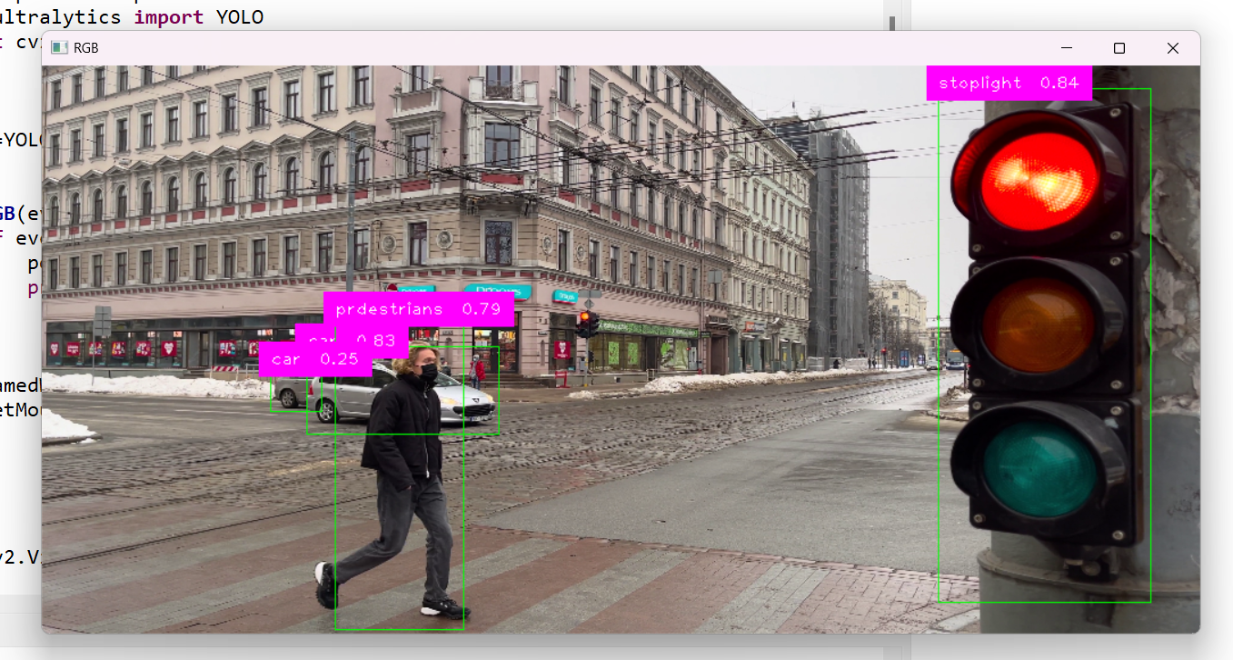

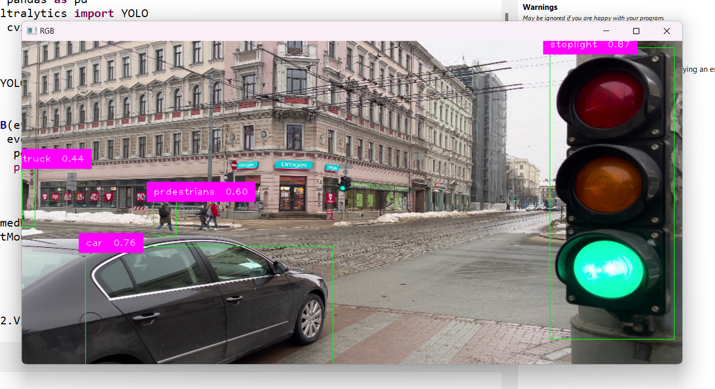

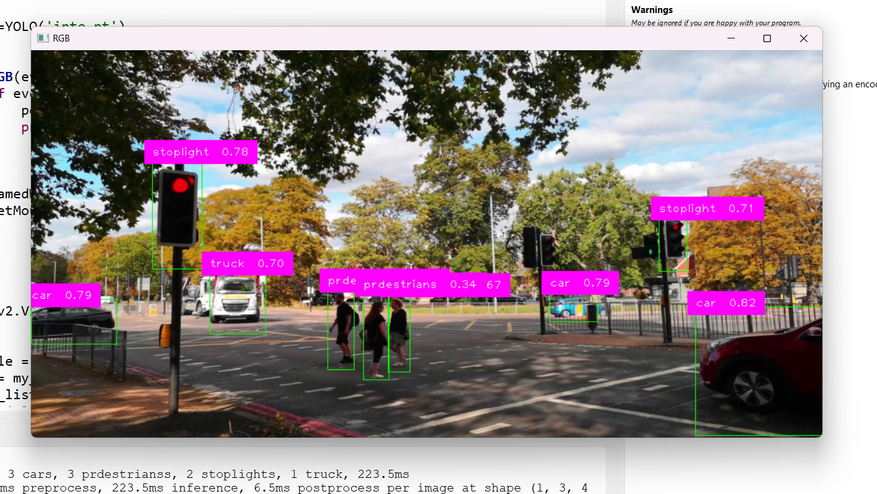

# APPENDIX

**A. Code Snippets**

**Provide relevant code snippets for key components of your project, such as YOLOv8 implementation, training, and OpenCV integration.**

**B. Dataset Details**

**Include details about the dataset, such as the number of images, annotations, and class distribution.**

**C. Model Configuration**

**Include the configuration files for the YOLOv8 model used in the project.**

**D. Evaluation Metrics**

**Present detailed results of model evaluation, including precision, recall, and mAP scores.**

**E. Screenshots and Visualizations**

**Include visualizations, such as detection results on sample images and screenshots of real-time detection in video streams.**

**F. Challenges and Solutions**

**Discuss any challenges faced during the project and the solutions implemented to overcome them.**

**G. Future Enhancements**

**Outline potential improvements and future directions for the project, such as fine-tuning on additional datasets or optimizing for specific scenarios.**

**Remember to adapt and expand each section based on the specific details of your project. Good luck with your project!**

# BIBLIOGRAPHY

1. Bayesian probability analysis: a prospective demonstration of its clinical utility in diagnosing coronary disease ROBERT DETRANO, M.D., PH.D., JOHN YIANNIKAS, M.D., ERNESTO E. SALCEDO, M.D., GuSTAVo RINCON,

M.D., RAYMUNDO T. Go, M.D., GEORGE WILLIAMS, PH.D., AND JUDY LEATHERMAN, B.S

1. Marateb HR, Goudarzi S. A noninvasive method for coronary artery diseases diagnosis using a clinically-interpretable fuzzy rule-based system. J Res Med Sci. 2015 Mar;20(3):214-23. PMID: 26109965; PMCID: PMC4468223.
2. Little,Max. (2008). Parkinsons. UCI Machine Learning Repository. [https://doi.org/10.24432/C59C74.](https://doi.org/10.24432/C59C74)
3. Little MA, McSharry PE, Hunter EJ, Spielman J, Ramig LO. Suitability of dysphonia measurements for telemonitoring of Parkinson's disease. IEEE Trans Biomed Eng. 2009 Apr;56(4):1015. doi: 10.1109/TBME.2008.2005954. PMID: 21399744; PMCID: PMC3051371.
4. Smith JW, Everhart JE, Dickson WC, Knowler WC, Johannes RS. Using the

ADAP Learning Algorithm to Forecast the Onset of Diabetes Mellitus. Proc Annu Symp Comput Appl Med Care. 1988 Nov 9:261–5. PMCID: PMC2245318.

1. Mapping Recommendation System for Health Care - Diagnosis and Treatment Process Navin K, Mukesh Krishnan MB
2. <https://docs.streamlit.io/library/api-reference>